AI Statement
Please delete as applicable:

- I declare that no part of this submission has been generated by AI software.
- I declare that this submission has contributions from AI software, which includes the following:

Software Name

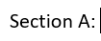
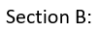
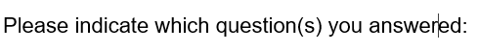

References

