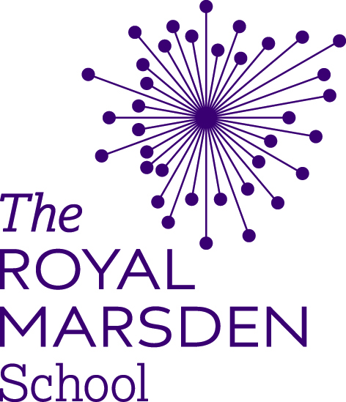
Extenuating Circumstances Report Form

The attached form should be used to report circumstances that you consider have had an impact on your academic performance and/or your ability to study.

When completing this form please read:
- The Royal Marsden School – Extenuating Circumstances Self Certification Policy 2019/20
- The UEA Extenuating Circumstances Regulations for Partners 2019/20
The policies are available on Moodle here. Submit your completed form to: StudentSupportSevicesRMS@rmh.nhs.uk.

Self-Certification – Extension of 5 working days
- If you require an extension to an assignment deadline, extensions of a maximum of 5 working days shall be approved automatically on two occasions per academic year* (but not within the same module) on receipt of a completed Extenuating Circumstances Report form by the Assessments Officer.
- Self-Certification requests must be submitted 5 working days in advance of and up to the assignment submission deadline. All requests submitted after the deadline must have supporting evidence.
- Self-Certification requests must state the extenuating circumstances that have led to the request. For information the following circumstances are normally considered to be acceptable grounds for requesting an extension:
- Illness
- Significant adverse personal/family circumstances
- Bereavement of close relative or significant other
- Other significant exceptional factors which have impacted on your studies

The following are NOT acceptable reasons for requesting a deadline extension:
- Bunching of coursework deadlines
- Personal computer/printer problems
- Holidays
- Financial issues
Extenuating Circumstances – Extension of more than 5 working days
- Where you find that you need an extension in excess of 5 working days, additional requests must be submitted on the Extenuating Circumstances Report Form with supporting evidence either included or provided within 5 working days.
*for students whose course/stage start date is not September, reference to the academic year is taken to mean from the month you commenced your studies for that stage of study
Extenuating Circumstances Report Form

The attached form should be used to report circumstances that you consider have had an impact on your academic performance and/or your ability to study.

When completing this form please read:
- The Royal Marsden School – Extenuating Circumstances Self Certification Policy 2019/20
- The UEA Extenuating Circumstances Regulations for Partners 2019/20
The policies are available on Moodle here. Submit your completed form to: StudentSupportSevicesRMS@rmh.nhs.uk.

1. Personal details
Student name
Student ID number |  | Level |  | Attempt
Email address
Module title
Module Leader

2. What is the nature of the circumstances you are reporting?
Health | Personal
Bereavement | Other

3. What type of adjustment you are seeking?
Self-certification for 5 working day extension to submission deadline
Extension of more than 5 working days to submission deadline (evidence required) (see section 4.3(c))
Delayed Assessment/Reassessment (D/AR - see section 5.2(b))
Consideration by Board of Examiners (see section 5.2(c))
Other (repeat of year/break in studies etc) (see section 5.2(d))

4. How long have your difficulties been impacting on your studies?
From date

5. For which specific assignments would you like these circumstances to be considered?
Module code | Assignment type (exam, coursework etc) | Original Submission /test date | Requested new submission date

6. Please give details of your circumstances and how they have impacted on your ability to study effectively or complete assessments (the School will use the UEA Extenuating Circumstances Regulations for Partners 2019/20 when considering your request).
Please indicate below the supporting evidence you have attached or will submit by the deadline (see section 4.12, page 12)

7. Please provide details if you have consulted with anyone to seek help in resolving your difficulties (eg Personal Tutor, Module Leader etc.)

8. Please outline how and when you expect your personal difficulties to be resolved?

9. Are you still participating in your course?
Yes No

If no, please confirm:
The date that you last participated:
Would you like to request an authorised break in your studies? Yes No

Please check the information provided and sign below.
If you are reporting circumstances for a self-certification extension, please check that your circumstances comply with the UEA Extenuating Circumstances Regulations for Partners 2019/20 and sign below to confirm:
Signature: |  | Date:

PLEASE SUBMIT YOUR COMPLETED FORM AND SUPPORTING EVIDENCE TO StudentSupportServicesRMS@rmh.nhs.uk

What happens next?

- Your application will be considered via a number of processes depending on the nature of the submission.
5.1 If you are self-certifying, which you are permitted to do twice per year, but not within the same module, you should assume that this request has been granted and you will see your amended deadline on Moodle as no later than 16:00 on the new date.
5.2 In all other cases, you will be contacted with regard to the outcome of your application. Note that the submission time will remain as no later than 16:00 on the new assignment deadline.
However, you should not assume that your application will be approved. If your application relates to an extension deadline for which you are not self-certifying, you are advised to continue to work towards the original deadline until you receive notification of the outcome. Following submission of your work, it will be marked and returned within 25 working days.

